SMART ALCOHOL INTOXICATION DETECTION AND PREVENTION SYSTEM USING AI
Conclusion, Future Scope and References
Department of Computer Science and Engineering, TKR College of Engineering and Technology (Autonomous)
Batch A6 (CSE-A) · Academic year [ACADEMIC YEAR]
Table 1: Project team
S.No. | Student name | Roll number
1 | B PRANITHA | 23K91A0522
2 | BANTU KAVYA | 23K91A0531
3 | DASARI VIVEKA SARVESHWARI | 23K91A0560
4 | BEKKAM VAMSHI | 23K91A0534

Project guide: N. PADMAVATHI
Chapter and section numbers quoted in the text (for example Section 6.6 or Chapter 8) refer to the full project report, 17.Final Document. Figures and tables in this document are numbered from 1.

CHAPTER 9: CONCLUSION

9.1 Summary
The project set out to build a smart alcohol intoxication detection and prevention system using ai. What it delivers is narrower and is stated here without softening: the Smart Rider Impairment Warning System for Two-Wheelers, a stationary demonstration prototype that reads a person's eyes and head through a webcam and returns Normal, Possible impairment or drowsiness or Unable to assess, with the reason. A MediaPipe face-landmark module, a six-point eye aspect ratio, seven quality gates, personal calibration and explainable duration rules run on a laptop CPU at about 30 frames per second; a Tkinter application and a FastAPI + React application expose them, and a numeric event history, CSV export, a threshold editor and an offline evaluation pipeline complete the system. It does not detect alcohol, it contains no deep-learning classifier, and it takes no prevention action.

9.2 Objectives achieved
Of the six objectives in the batch description, two were achieved (real-time face and landmark capture; continuous inference with an alert), two were achieved in part (impairment cues - without gaze deviation; evaluation - on eye state and degraded conditions, not on intoxication), and two were not achieved: training a deep-learning sober-versus-intoxicated classifier and integrating a prevention action. The reasons are plain. No labelled intoxication recordings were available to the team, and a classifier trained on synthetic data would have been meaningless; and a prevention action needs vehicle integration that a laptop demonstration cannot provide. Section 8.11 gives the objective-by-objective table.

9.3 Key findings
• On 2,423 public face images the six-point EAR computed by the shipped pipeline separates closed from open eyes with a ROC AUC of 0.989; at the default threshold of 0.21 closed-eye recall is 99.2% but open-eye specificity is only 85.5%. A threshold near 0.17 gives 94.7% accuracy in-sample, so the default is conservative and personal calibration matters.
• The quality gates fail safe (no verdict) for darkness, blur, opaque sunglasses and a covered eye, but they are strict: only 44.1% of the 100-pixel images pass, and halving brightness already blocks assessment.
• On scripted streams the default rules never fire on normal blinks and warn only after about 2.5 s of continuous closure; a closure of two seconds goes unwarned. Closure and persistence trade sensitivity against false alerts, and their sum is what counts.
• A camera frame costs about 31 ms through the API on a laptop CPU, so the design is not computation-limited.
• The software is verified by 20 unit tests and 34 API checks, and every figure in this report can be regenerated by the measurement scripts.
• The offline research pipeline works mechanically, but its only report comes from a synthetic file; it is a pipeline check, not a result.

9.4 Practical applications
• A teaching and demonstration tool for how eye-based fatigue cues, quality gating and explainable rules work, with scripted scenarios that need no camera.
• A reusable software scaffold - vision module, rule engine, API, web interface and evaluation pipeline - for a future study that does have labelled data.
• A drowsiness-type warning prototype that could, after validation on riders, support a fatigue-awareness feature; it should not be used to decide whether anyone is fit to ride.

9.5 Known limitations
• Not an alcohol detector. Closed eyes, low EAR and head tilt have many causes (sleep loss, medication, illness, eye shape); open eyes do not establish alertness, and sober people can be flagged.
• No intoxication data. No labelled sober/intoxicated recordings exist in this project, so no accuracy for intoxication is claimed, and the deep-learning classifier requested in the objectives was not built.
• No prevention action. The system warns on screen and by bell only; it cannot stop a vehicle or notify a contact.
• Conservative default threshold. On public data the default EAR threshold of 0.21 labels about one open eye in seven as closed; calibration is the intended remedy but was not measured per person.
• Strict quality gates. Roughly 44 % of the 100-pixel test images pass; halving the image brightness already blocks assessment; a few sunglasses images passed the gates.
• Slow reaction. With the default rules a closure shorter than about 2.5 s never warns, and the closed-fraction rule needs 8-10 s of history.
• Single data source and machine. The eye-state measurement uses one public still-image dataset whose classes come from different sources; no helmet, visor, glasses-in-motion, vibration, night or demographic study was done; all timings come from one i5-12500 laptop without a GPU.
The two figures below summarise the measurements behind the conclusions: the first shows how closed-eye recall, open-eye specificity and accuracy move with the EAR threshold on the public CEW images (the default of 0.21 is conservative), the second shows the ROC curve of EAR on the images that passed the quality gates. Both concern eye state only, not alcohol.
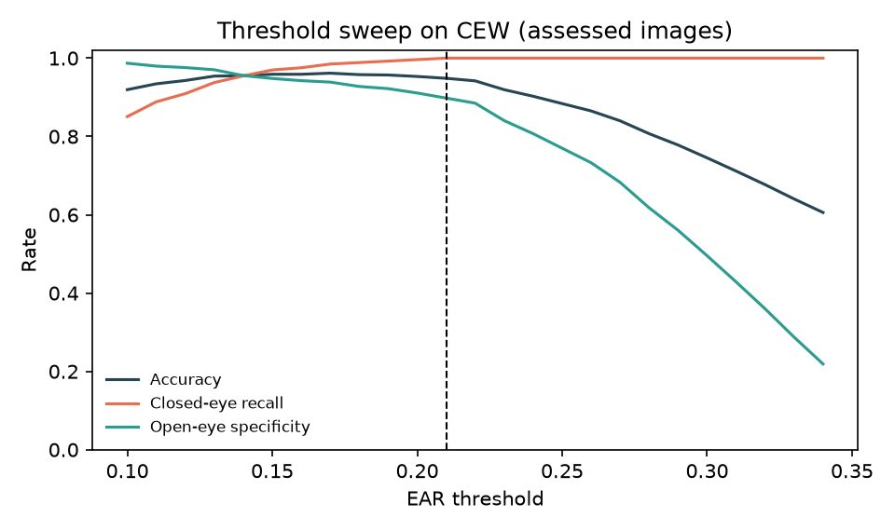
Figure 1: Accuracy, closed-eye recall and open-eye specificity against the EAR threshold
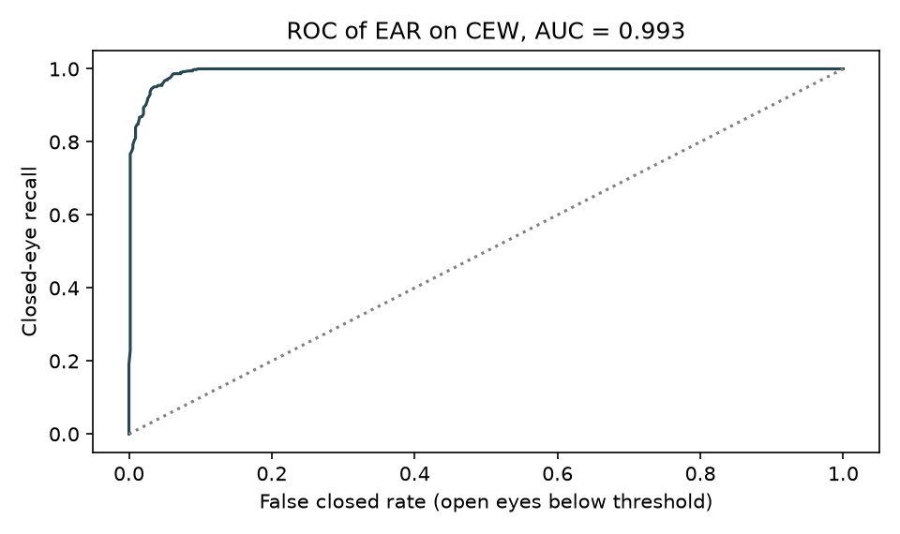
Figure 2: ROC curve of the eye aspect ratio as a closed-eye score (assessed CEW images)

CHAPTER 10: FUTURE SCOPE

10.1 Improvements to the model
• Collect a consented, labelled sober/intoxicated video dataset under a documented protocol with measured blood or breath alcohol, and evaluate with subject-disjoint splits through the existing research.py. Companion work reports high accuracy on its own video data [2], but its source videos are not generally available, so new data would be needed.
• Add gaze and eye-movement features (saccade speed, nystagmus-like jitter, gaze deviation) that the objectives name and that standardised field tests use as cues [18].
• Learn a temporal model over windows of EAR, roll and gaze features, and compare it with the rules on the same held-out subjects before letting it influence live decisions.
• Tune thresholds on held-out subjects, replacing the in-sample 0.17 suggestion; compare personal calibration with a fixed lower threshold using several images per person.
• Make the gates helmet-, visor- and low-light-aware: replace the brightness-sensitive sharpness gate by a scale-free measure and test on night and helmet footage.

10.2 Additional features
• A prevention action: a vehicle interface that inhibits ignition or notifies a registered contact, designed with a safety review and a fail-safe default.
• A voice or haptic channel and wearable sensing, in the spirit of the base paper's voice interface [1] and of smartwatch-based drunk-driving detection [3].
• Real user accounts, per-rider calibration profiles and an audit log.
• A reviewer screen that lets a researcher label events, feeding the evaluation pipeline.

10.3 Scalability and deployment
• Run the vision path on an embedded device with an infrared camera, as the base paper does on a Jetson Orin Nano, and measure frame rate, heat and power on the motorcycle.
• Package the API and the built front end in a container behind a reverse proxy with HTTPS, replace the demo token by a proper identity provider, and add rate limits.
• Add monitoring of latency, the share of Unable to assess and alert counts to detect drift in the field.

10.4 Further research
• A formal user and rider study with ethics approval, including false-alarm tolerance, alert design and over-reliance on a Normal verdict.
• Fusion of camera cues with driving behaviour or wearable signals, since wrist-based detection has shown promise on a test track [3].
• Fairness testing across skin tones, ages, eye shapes and eyewear, which this project could not do.
• Comparison of EAR variants, such as the upper-lid EAR-4 of the base paper, against six-point EAR on the same data.

REFERENCES
[1] C.-L. Feng and T.-H. S. Li, "Robust driver state assessment on an embedded platform using a fuzzy belief rule-based fusion of eye aspect ratio and voice commands," IEEE Access, vol. 14, pp. 36158-36175, 2026, doi: 10.1109/ACCESS.2026.3670924.
[2] B. Baroutian, A. Aghaei, and M. Ebrahimi Moghaddam, "Detection of intoxicated individuals from facial video sequences via a recurrent fusion model," arXiv:2512.04536, Dec. 2025.
[3] R. Deuber et al., "Detecting drunk driving using off-the-shelf smartwatches," arXiv:2605.23663, May 2026 (manuscript under review).
[4] V. Mehta, D. P. Yadav, S. S. Katta, and A. Dhall, "DIF: Dataset of perceived intoxicated faces for drunk person identification," arXiv:1805.10030, 2018 (revised 2019).
[5] L. P. Acharya, "Infrared deep learning system for non-invasive drunk detection and alcohol level classification," Iowa State Univ., Ames, IA, USA, Dec. 2024. [Online]. Available: https://dr.lib.iastate.edu/handle/20.500.12876/105973
[6] F. Deiana, J. Jackson, and C. Periago, "Development and verification of a testing methodology for driver alcohol intoxication detection systems," in Human Systems Engineering and Design (IHSED2026): Future Trends and Applications, AHFE Int., 2026, doi: 10.54941/ahfe1008145.
[7] "Alcohol detection and vehicle immobilization system for enhanced taxi driver safety and drunk driving prevention," in Proc. 9th Int. Conf. Trends in Electronics and Informatics (ICOEI), 2026 (entry recorded in the batch literature survey; not located online).
[8] C.-H. Chai, S. F. Abdul Razak, S. Yogarayan, and R. Shanmugam, "Drunk driver detection using thermal facial images," Information, vol. 16, no. 5, Art. no. 413, 2025.
[9] T. Soukupova and J. Cech, "Real-time eye blink detection using facial landmarks," in Proc. 21st Computer Vision Winter Workshop, Rimske Toplice, Slovenia, Feb. 2016.
[10] Y. Kartynnik, A. Ablavatski, I. Grishchenko, and M. Grundmann, "Real-time facial surface geometry from monocular video on mobile GPUs," arXiv:1907.06724, 2019.
[11] C. Lugaresi et al., "MediaPipe: A framework for building perception pipelines," arXiv:1906.08172, 2019.
[12] F. Song, X. Tan, X. Liu, and S. Chen, "Eyes closeness detection from still images with multi-scale histograms of principal oriented gradients," Pattern Recognit., vol. 47, no. 9, pp. 2825-2838, Sep. 2014, doi: 10.1016/j.patcog.2014.03.024.
[13] G. B. Huang, M. Ramesh, T. Berg, and E. Learned-Miller, "Labeled faces in the wild: A database for studying face recognition in unconstrained environments," Univ. Massachusetts Amherst, Amherst, MA, USA, Tech. Rep. 07-49, Oct. 2007.
[14] C.-H. Weng, Y.-H. Lai, and S.-H. Lai, "Driver drowsiness detection via a hierarchical temporal deep belief network," in Computer Vision - ACCV 2016 Workshops (Lecture Notes in Computer Science). Cham, Switzerland: Springer, 2017, pp. 117-133, doi: 10.1007/978-3-319-54526-4_9.
[15] Federal Motor Carrier Safety Administration, "PERCLOS: A valid psychophysiological measure of alertness as assessed by psychomotor vigilance," Tech Brief FHWA-MCRT-98-006, Washington, DC, USA, Oct. 1998.
[16] J. A. Stern, D. Boyer, and D. Schroeder, "Blink rate: A possible measure of fatigue," Human Factors, vol. 36, no. 2, pp. 285-297, 1994, doi: 10.1177/001872089403600209.
[17] World Health Organization, "Global status report on road safety 2023," Geneva, Switzerland, Dec. 2023.
[18] National Highway Traffic Safety Administration, "DWI detection and standardized field sobriety testing (SFST) participant manual," U.S. Dept. Transportation, Washington, DC, USA, 2023 ed.
[19] G. Bradski, "The OpenCV library," Dr. Dobb's Journal of Software Tools, 2000.
[20] C. R. Harris et al., "Array programming with NumPy," Nature, vol. 585, pp. 357-362, Sep. 2020, doi: 10.1038/s41586-020-2649-2.
[21] J. D. Hunter, "Matplotlib: A 2D graphics environment," Comput. Sci. Eng., vol. 9, no. 3, pp. 90-95, 2007, doi: 10.1109/MCSE.2007.55.
[22] S. Ramirez, "FastAPI framework, high performance, easy to learn, fast to code, ready for production." [Online]. Available: https://fastapi.tiangolo.com
[23] Meta Platforms, Inc., "React: The library for web and native user interfaces." [Online]. Available: https://react.dev
[24] Google AI Edge, "Face landmarker guide for Python," MediaPipe Solutions documentation. [Online]. Available: https://ai.google.dev/edge/mediapipe/solutions/vision/face_landmarker/python
[25] T. Fawcett, "An introduction to ROC analysis," Pattern Recognit. Lett., vol. 27, no. 8, pp. 861-874, Jun. 2006, doi: 10.1016/j.patrec.2005.10.010.
[26] D. M. W. Powers, "Evaluation: From precision, recall and F-measure to ROC, informedness, markedness and correlation," J. Mach. Learn. Technol., vol. 2, no. 1, 2011, arXiv:2010.16061.
[27] S. Abtahi, M. Omidyeganeh, S. Shirmohammadi, and B. Hariri, "YawDD: A yawning detection dataset," in Proc. 5th ACM Multimedia Syst. Conf. (MMSys), 2014, pp. 24-28, doi: 10.1145/2557642.2563678.
[28] Q. Ji, Z. Zhu, and P. Lan, "Real-time nonintrusive monitoring and prediction of driver fatigue," IEEE Trans. Veh. Technol., vol. 53, no. 4, pp. 1052-1068, Jul. 2004, doi: 10.1109/TVT.2004.830974.
[29] A. Radford, J. W. Kim, T. Xu, G. Brockman, C. McLeavey, and I. Sutskever, "Robust speech recognition via large-scale weak supervision," in Proc. Int. Conf. Mach. Learn. (ICML), PMLR vol. 202, 2023, pp. 28492-28518.
[30] J.-B. Yang, J. Liu, J. Wang, H.-S. Sii, and H.-W. Wang, "Belief rule-base inference methodology using the evidential reasoning approach - RIMER," IEEE Trans. Syst., Man, Cybern. A, Syst., Humans, vol. 36, no. 2, pp. 266-285, Mar. 2006, doi: 10.1109/TSMCA.2005.851270.

